SENIOR SIX TERM 3 CHEMISTRY 2026

TOPIC 1/2: Organic Chemistry III
Topic competency: The learner analyses the chemical properties, industrial applications, and environmental impacts of amines and polymers, evaluates their social and ecological implications, and proposes innovations and sustainable solutions for addressing challenges in their use and disposal.

Amines
These are organic derivatives of ammonia

Classification of amines
According to the number of alkyl groups attached to the nitrogen atom
- Primary amines: have only one alkyl group attached to a nitrogen atom. i.e. RNH₂ Examples



CH
3
NH
2

methylamine

CH
3
CH
2
NH
2

ethylamine

CH
3
CHCH
2
CH
3

2
-
aminobutane

NH
2

- Secondary amines: have two alkyl groups attached to a nitrogen atom, R₂NH Examples



CH
3

N CH
3

Dimethylamine

H

CH
3
NHCH
2
CH
3

Ethylmethylamine

(
in alphabetical order
)

- Tertiary amine: have 3 alkyl groups on the nitrogen atom i.e, R₃N, where R is an alkyl group.


CH
3

N CH
3

Trimethylamine

CH
3

Physical properties of amines
1. Boiling and melting points
- Amines are polar compounds and therefore have higher melting and boiling points than non-polar compounds of similar molecular mass due to dipole-dipole intermolecular forces or hydrogen bonding,
- Primary and secondary amines have higher melting points and boiling points than tertiary amines because tertiary amine do not form intermolecular hydrogen bonds
- Primary amines have higher melting and boiling points than secondary amines because they form many hydrogen bonds per molecule.

2. Solubility
Amines are soluble in water because they can form hydrogen bonds with water but the solubility decrease with alkyl chain length. Generally, primary amines are more soluble than secondary amines than tertiary amines because they form many hydrogen bonds in water.

3. Basicity of amines

Like ammonia, amines dissolve in water to form alkaline solution.
RNH₂ + H₂O ↔ RN⁺H₃ + OH⁻(aq)
The strength of the alkaline solution is measured by the function Kb

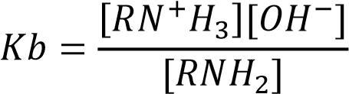
The higher the Kb the stronger the base or the higher the hydroxyl ion concentrations.
The ability to form alkaline solution, by amines, is due to the presence of a lone pair of electron on the nitrogen atom.
- Groups (such as alkyl groups) that donate electrons increase the electron density of the lone pair on the nitrogen atom. This increases the ability of alkylamine to attract a proton from water to release hydroxide ions.

Thus, secondary amines are stronger bases than primary amines than ammonia because secondary amine has two electron donating groups, primary amines has one, whereas, amines have none.

However, tertiary amines are weaker bases than either secondary or primary amines because their iminium ions are poorly solvated or hydrated or are unstable.

- Groups that withdraw electrons from nitrogen atoms like phenyl group, make amines weaker bases because they reduce the ability of the lone pair of electron on the nitrogen atom and its ability to attract a proton from water.
Example 1
Explain the following observations
(i) The basic strength of the following amine is in order.
NH₂
< NH₃ < (CH₃)₃N

Solution
Trimethylamine is a stronger base than ammonia because the methyl groups donate electrons to the nitrogen atom. This increases the density of alone pair of electron on the nitrogen atom on trimethylamine and its ability to attract a proton from water and form hydroxyl ions.
Phenylamine is a weaker base than ammonia because the phenyl group pulls electrons from the nitrogen atom. The reduction of electron density of alone pair on the nitrogen atom reduces the ability of the lone pair to attract a proton from water and form hydroxyl group. (ii) The boiling points of the following amines are
CH₃CH₂CH₂NH₂ |  | = 66.8⁰C
CH₃CH₂NHCH₃ |  | = 45.4⁰C
(CH3)3CN |  | = 7.70C

Solutions
Propylamine has the highest boiling point has the highest boiling point because it has two hydrogen atoms on the nitrogen atom which form many intermolecular hydrogen bonding.
The hydrogen bonds necessitate high temperature to break; hence high boiling point.
Ethylmethylamine has one hydrogen bond on the nitrogen atom and thus forms fewer hydrogen bonds leading to lower boiling point.
Trimethylamine lack a hydrogen atom on a nitrogen atom and is incapable of forming intermolecular hydrogen bond leading to the lowest boiling point.
(iii) The acid constants Ka for the following amines are:
Amine | Ka (moldm⁻³)
(CH₃)₃N | 9.70
CH₃CH₂CH₂NH₂ | 10.67

Solution
Trimethylamine (CH₃)₃N is a weaker base than propylamine because it form unstable aqueous ammonium ions
Chemical properties
- They react with acids to form salts Example
CH₃NH₂ + HCl CH₃N⁺H₃Cl⁻
- Primary and secondary amines react with alkanoyl halides to form amides
Example 2
CH₃COCl + CH₃NH₂ CH₃CONHCH₃
Mechanism
H2NCH3
C
H
3
C
O
C
l
C
H
3
C
O
C
l
H
2
N
C
H
3
C
H
3
C
O
N
C
H
3
H
-
H
C
l

Trial 1
Complete and write a mechanism
CH₃COBr + CH₃CH₂NH₂
Solution
CH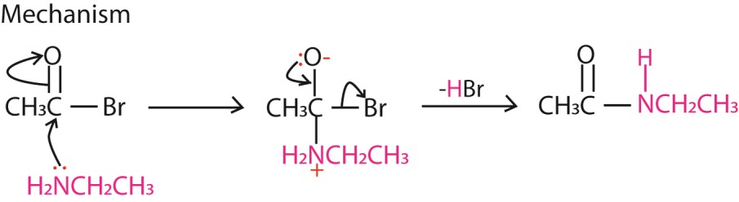 COBr + CH CH NH CH CONHCH CH
3
3
2
2
3
2
3

3. Primary amines undergo condensation reaction with carbonyl compounds between pH 4 -5 to form imines. At lower pH the amine is protonated as well making it a weaker nucleophile.
Example 3
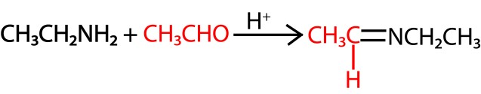
MECHANISM
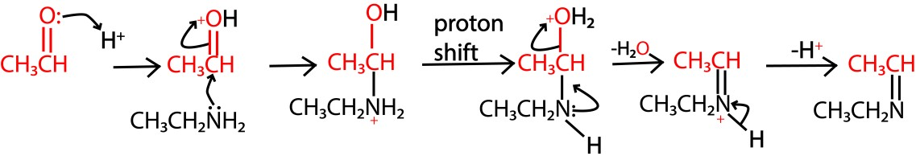

Exercise 2
Complete the following equations and write appropriate mechanism.
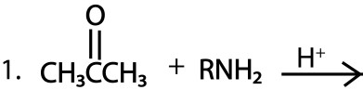
Solution
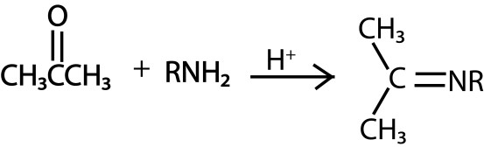
Mechanism
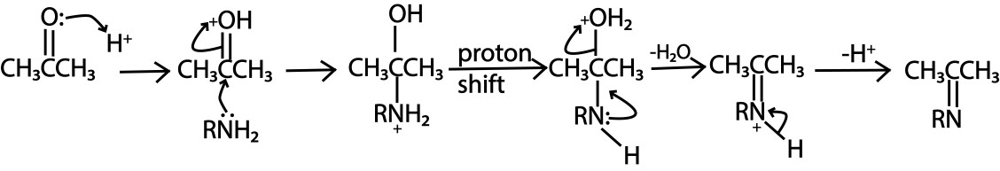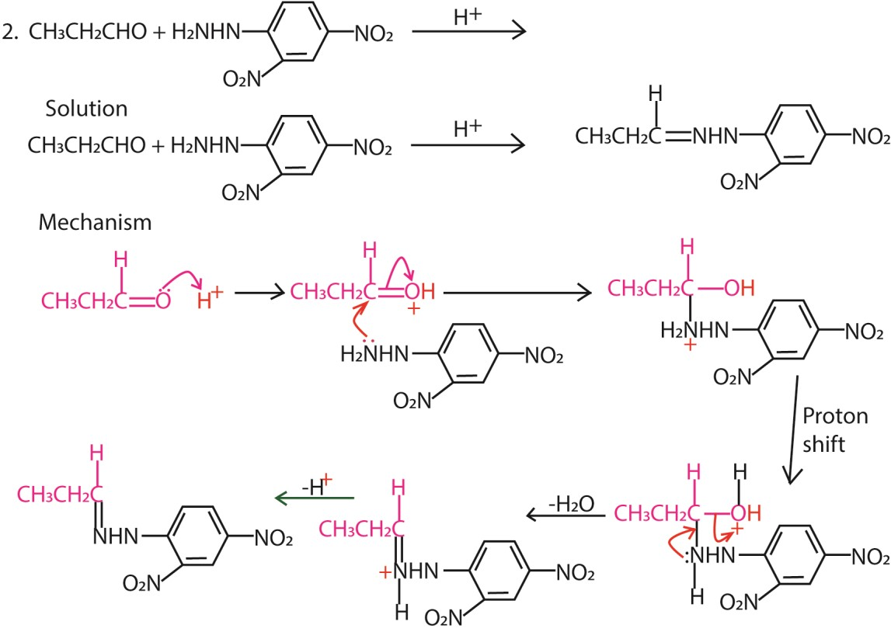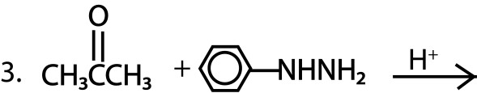

Solution
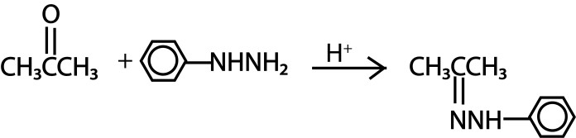

Mechanism
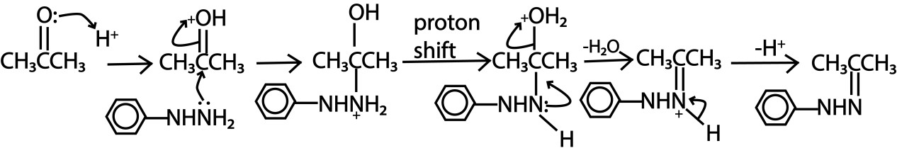

Distinguishing between primary, secondary and tertiary amines
A. Reagent: nitrous acid (NaNO₂, HCl (0-5⁰C))

Observations
- Primary amine: effervescence
Equation
RNH₂ + NaNO₂ + 2HCl RCl + N₂(g) +H₂O + NaCl
- Secondary amines: yellow oil liquid
Equation
R₂NH + NaNO₂ + HCl R₂N-NO + NaCl + H₂O
- Tertiary amines: no observable change du to the formation of soluble diazonium salts
Equation
R₃N + NaNO₂ + 4HCl RN₂Cl + 2RCl + NaCl + 2H₂O
- Aromatic amine: no observable change du to the formation of soluble diazonium salts
Equation
ArNH₂ + NaNO₂ + 2HCl ArN₂Cl + NaCl + 2H₂O

Reaction of aromatic diazonium salts
A
r
-
N
2
A
r
-
O
H
A
r
-
C
l
A
r
-
B
r
A
r
-
C
N
A
r
-
I
A
r
-
H
C
u
2
O
,

C
u
2
+
,

H
2
O
C
u
I
C
u
B
r
C
u
C
N
K
I
H
3
P
O
2
,

H
2
O

B. The Hinsberg test

Procedure: a mixture of small amount of the amine and benzenesuplfonyl chloride is shaken potassium hydroxide, time allowed for the reaction to take place and then the mixture is acidified.

Primary amine for a colorless solution with potassium hydroxide, forming a precipitate when the mixture is acidified.

Secondary amine: forms a precipitate with potassium hydroxide insoluble when the mixture is acidified

Tertiary amine: no observable change

Preparation of amines
- Reaction of alkyl halides with ammonia Example

CH₃CH₂Cl CHNH³ ₃CH₂NH₂

Mechanism
H H
C
H
3
C
H
H
C
l
:
N
H
3
CH₃ NH₃ -H⁺ CH₃ NH₂
C
C
H H

- By reduction of nitroalkane

NO₂
NH₂
S
n
/
H
C
l
Or
NO₂
NH₂
1
.

F
e
,

H
C
l
2
.

O
H
- By Hofmann degradation
Amides with no substituent on the nitrogen atom react with solution of bromine or chlorine in sodium hydroxide to yield amines.
O
H₂O
R C NH₂ + Br₂ + 4NaOH RNH₂ + 2NaBr + 2Na₂CO₃ + 2H₂O

Example
₋
Br₂ / OH

CH₃CONH₂ CH₃NH₂

- By reduction of nitriles

i.e. RCN LiAlH 4, dry ether RCH2NH2 nitrile

Example

LiAlH₄, dry ether
CH₃CN CH₃CH₂NH₂

Nitrile can be obtained by reacting alkyl halides with potassium cyanide.

i.e. RCl + KCN RCN +KCl

- By reduction of oximes
i.e. RCH=NOH LiAlH 4, dry ether RCH2NH2.
Example
CH3CH=NOH LiAlH 4, dry ether CH3CH2NH2

Polymerization
A polymer is a high molecular mass species consisting of a regular repeating units or chemically similar units, linked by primary covalent bonds.
Polymerization is the process by which high molecular mass species are formed many chemically simialar units called monomers.
Types of polymerization.
- Addition polymerization: monomers add one to each other to form polymers without loss of any molecule.
CH₂CH₂
  - Alkenes undergo addition polymerization to form polyalkenes nCH2 CH2 * n * ethene polyethene
Other common polyalkenes are:

Monomer | Structure | Name of the polymer
Vinyl monomers
Propene | CH₃CH=CH₂ | Polypropene
Vinylchloride | CH₂=CHCl | Polyvinylchloride (PVC)
Vinylacetate | CH₂=CHOCOCH₃ | Polyvinylacetate
Styrene | CH₂=CH- | Polystyrene
acrylonitride | CH₂=CHCN | Polyacrylonitride
Acrylic monomers
Acrylic acid | CH₂=CHCOOH | Polyacrylic acid
Methylacrylate | CH₂=CHCOOCH₃ | Polymethylacrylate
butylacrylate | CH₂=CHCOOC₄H₉ | Polybutylacrylate
Methacrylic acid | CH₂=C(CH₃)COOH | Polymethacrylic acid
Methylmethacrylate | CH₂=C(CH₃)COOCH₃ | Polymethylmethacrylate
Ethylmethacrylate | CH₂=C(CH₃)COOC₂H₅ | Polyethylmethacrylate
Acrylamide | CH₂=CHCONH₂ | Polyacrylamide

  - Conjugated dienes undergo addition polymerization to form polydienes.
Examples
    - CH₂ CH CH CH₂*
n
*
C
H
2
C
H
C
H
C
H
2
1,3-butadiene

    - CH₂CH₂ *
C
C
H
*
C
H
2
C
C
H
C
H
2
n
CH₃ CH₃
Isoprene

- Condensation polymerization is formation of big molecules called polymers from small molecules called monomers accompanied by loss of small molecules such as water, ammonia e.t.c
Examples
1. nCH CH₂ + nCH₃OOCCOOCH3 OCH₂CH₂OC *OCH₃
C
n
O
2
*
H
OH OH CH₃OH O
Ethane-1,2-diol Polyster

O O
C
C
O
O
C
O
n
*
H
O
OCH₂CH₂OC*
nCH CH₂ + n
2
OH ^{OH} O ₂O Polyster H
Ethane-1,2-diol Pthalic
anhydride

3. Polyamide O OH
N
H
HOOC(CH₂)₄COOH + H₂N(CH₂)₆NH₂HO *C(CH₂)₄C(CH₂)₆ N*nH adipic acid hexane-1,6-diamineNylon 6,6
H2O
Thermoplastic and thermosetting polymers
Thermoplastic polymers are polymers that soften and can be remolded on heating, e.g. polyethene.
Thermosetting polymers are polymers that cannot be remolded on heating. E.g. phenolic and epoxy resins.

TOPIC 2/2: 13: Reaction Kinetics
Competency: The learner evaluates factors influencing reaction rates, and applies the principles of reaction, mechanisms and rate laws to predict the speed of chemical reactions under various conditions.

Chemical kinetics
It is a branch of chemistry that deals with the measurement of reaction velocities/rates and determination of mechanisms by which reactants are converted into products.

The knowledge of chemical kinetics is useful when altering the rates of chemical reaction is needed. For instance, manufacturers of fertilizers aim at speeding up the formation of ammonia from nitrogen and hydrogen whereas a car manufacturer wishes to slow down the rate at which iron rust.

Rates of reaction
Reaction rate is the speed at which a chemical reaction proceeds. It is often expressed in terms of either the concentration (amount per unit volume) of a product that is formed in a unit of time or the concentration of a reactant that is consumed in a unit of time.

Consider the reaction
A → product (p) …………………………………………… (I)
The rate of the reaction or reaction velocity may be defined as the rate of disappearance of the reactant (A) or the rate of appearance or formation of the product (P) with respect to time.

Thus rate =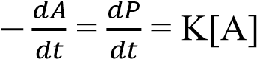

Where, K, is the rate constant.

In general for a reaction

aA +bB → cC + dD ………………………………………(II)

The rate of reaction is given as

Rate = 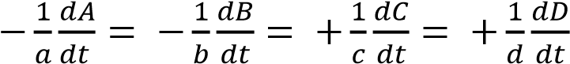

Since the reaction depends on the concentration of the reactants, the rate equation for the reaction in (II) can be expressed in a rate equation represented as

Rate = K[A]^{x}[B]^{y}.

Definitions terms in a rate law
(i) [A] is molar concentration of reactant A (ii) x is the order of reaction with respect to A (iii) y is the order of reaction with respect to B.
- The algebraic sum (x+y) is the overall order of the reaction. i.e. order of reaction is the sum power dependence of the rate on the concentration of each reactant.
- K is the rate constant of the reaction is a proportionality factor in the rate law of chemical kinetics that relates the molar concentration of reactants to reaction rate.
- Stoichiometry of a reaction is the quantitative relationships of the amount of products and reactants in a given reaction

The values of x and y are often 1 or 2 and rarely 0, 3, fraction or negative number. These values x and y are experimentally determined values and cannot be predicted until one has carried out the experiment. The order of the reaction has nothing to do with stoichiometry of the equation for the reaction.

For example, a simple reaction between bromated (V) ions, bromide ions and hydrogen ions to give bromine is represented by the equation:

BrO₃⁻(aq) + 5Br⁻(aq) + 6H⁺(aq) → 3Br₂(aq) + 3H₂O(l)

This has a complex rate equation from kinetic measurements as expressed below:

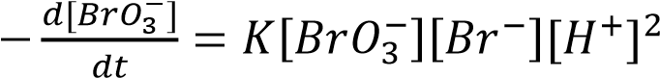

Determining the order of reaction
The order of a reaction can be found by comparing the initial rates of two more or reactions at known initial concentrations.

Example 1
The following results obtained for a reaction between A and B; can be used to determine the order of reaction with respect to A and with respect to B and the rate constant.

Run | Concentration (moldm⁻  ³)  A B |  | Initial rate (moldm⁻³)
(a)  (b)  (c)  (d)  (e) | 0.50  0.50  0.50  1.0  2.0 | 1.0  2.0  3.0  3.0  3.0 | 2.0  8.0  18.0  36.0  72.0

Method
Rate equation = K[A]^{x}[B]^{y}

To obtain x, which compare reactions in which the concentrations of B are constant but those of A vary such as (d) and (e):

2 = 2^{x}
x = 1
To obtain y, which compare reactions in which the concentrations of A are constant but those of B vary such as (b) and (a):

4= 2^{y} => y = 2

Calculating the rate constant, K,
We substitute for x and y in any of the experiment above e.g. (a)

2 = K[0.5]¹x [1.0]²
K = 4.0dm⁶mol⁻²s⁻¹

Trial 1
- Explain terms:
  - Rate of reaction
  - Order of reaction
  - Stoichiometry of reaction
  - Rate constant
- For the reaction
A+ B → C
The following results were obtained for kinetic runs at the same temperature.
[A]₀ (moldm⁻³) | [B]₀ (moldm⁻³) | Initial rate (moldm⁻³s⁻¹)
0.20  0.40  0.40 | 0.10  0.10  0.20 | 0.20  0.80  0.80

Why do kinetic experiments carried out at constant temperature
- Find
  - the rate equation for the reaction,
  - the rate constant,
  - the initial rate of reaction, when [A]₀ = 0.60moldm⁻³ and [B]₀ = 0.3moldm-³.

Trial 2
Tabulated are values of initial rates for the reaction
2A + B → C +D

Experiment | [A]₀  (moldm⁻³) | [B]₀ (moldm⁻³) | Initial rate  (moldm⁻³ min⁻¹)
1 | 0.150 | 0.25 | 1.4 x 10⁻⁵
2 | 0.150 | 0.50 | 5.6 x 10⁻⁵
3  4 | 0.075  0.075 | 0.50  0.25 | 2.8 x 10⁻⁵  7.8 x 10⁻⁵
- Find the order of reaction with respect to A, the order of reaction with respect to B and overall order of the reaction.
- Find the value of the rate constant
- Find the initial rate of the reaction when [A]₀ = 0.120moldm⁻³ and [B]₀ = 0.22moldm-³.

Trial 3
The reaction between nitrous oxide and ozone is given by the equation

NO (g) + O₃(g) → NO₂ + O₂

Was studied in the lab at 25⁰C and the following results were obtained.
Exp.  21No. | [NO]moll⁻¹ | [O₃]moll⁻¹ | Rate (moll⁻¹s⁻¹)
1 | 1.00 x 10⁻⁶ | 3.00 x 10⁻⁶ | 0.66 x 10⁻⁴
2 | 2.00 x 10⁻⁶ | 3.00 x 10⁻⁶ | 1.32 x 10⁻⁴
3 | 1.00 x 10⁻⁶ | 9.00 x 10⁻⁶ | 1.98 x 10⁻⁴
4 | 2.00 x 10⁻⁶ | 9.00 x 10⁻⁶ | 3.96 x 10⁻⁴
5 | 3.00 x 10⁻⁶ | 9.00 x 10⁻⁶ | 5.9 x 10⁻⁴
- Write an expression for the rate equation for the reaction above.
- Determine the order of reaction with respect to NO and O₃.
- Write the true rate equation for the reaction. (d) Calculate the value of rate constant.

Trial 4

The kinetic data for the reaction between X and Y are shown in the table below
Expt. | [X] mol dm⁻³ | [X] mol dm⁻³ | Rate  Mol dm⁻³s⁻¹
1  2  3  4 | 0.30  0.30  0.60  0.60 | 0.15  0.30  0.30  0.60 | 1.5 x 10⁻²  3.0 x 10⁻²  6.0 x 10⁻²  12.0 x 10⁻²

- Determine the order of reaction with respect to
  - X
  - Y
- Determine the overall order
- Calculate the rate constant for the reaction and indicate its units.

Trial 5
The rate equation for a certain reaction is:
Rate = K[P][Q}²[R]
(a) State what would happen to the rate of reaction if
- the concentration of P and Q are kept constant, but that of R is doubled.
- the concentration of all species are halved
- the concentration of all species are doubled
(b) the following were obtained in a study of reaction between peroxodisulphate and iodide ions
Expt. No. | [S2O8)2-]  Moldm⁻³ | [I⁻]  Moldm⁻³ | Rate  Moldm⁻³ s⁻  1
1  2  3 | 0.024  0.048  0.048 | 0.024  0.024  0.012 | 9.60 x 10⁻⁶  1.92 x 10⁻⁶  9.60 x 10⁻⁶

- Write the rate equation
- Calculate the rate constant for the reaction and state its units

Reactions of various orders

1. First order reaction
A reaction is said to be order if the rate is proportional to the first power of concentration of reactants on which the reaction kinetics depends. That is, the rate law for the first order reaction is given by
Rate = K[A] or K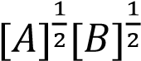

Identification of a first order reaction
First order reaction can be identified by the shapes of the following graphs.
All these graphs that show that the rate of reaction is proportional to the concentration of the reactant in the chemical reaction.
- Rate of reaction against concentration


[
A
]

Rate

Slope = K s
-
1

A straight line with positive gradient shows that the rate is proportional concentration of the reactant and that the reaction is thus first order.

- Concentration of the reactant against time.


[
A
]

t

Hyperbola shows that the rate of reaction is proportional to concentration of the reactant and thus a first order reaction

- For a first order reaction, a plot logarithm of concentration against time gives a straight line with negative gradient.


Log[A]

t

Slope =
-
K

A typical example of a reaction that follows a first order reaction mechanism is a radioactive disintegration process.

Definition
Radioactive decay (also known as nuclear decay, radioactivity, radioactive disintegration or nuclear disintegration) is the process by which an unstable atomic nucleus loses energy by radiation.

Integrated rate law for first order reaction

Consider a first order reaction

A→ P

If the initial concentration [A] of reactant (A) at time, t=0, is a moldm⁻³ and the concentration of product, P, after time t is x moldm⁻³; then concentration of A at time, t, will be (a-x) moldm⁻³.

Then, the rate of reaction as the rate of formation of the product is represented as

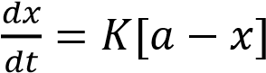

Or, separating variables;

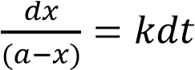

To get relationship between concentration and time, integrate both sides. i.e.
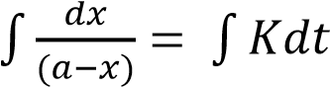

-ln(a-x) = Kt + C

At time, t = 0, x = 0, thus, C= -lna

Substituting for C we derive the relationship:

lna-ln(a-x) =Kt

Or
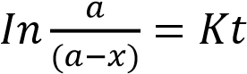

The plot of 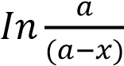 against time gives a straight line and the slope of this graph is equal to Ks⁻¹.



𝐼𝑛
𝑎

𝑎

𝑥

t

Slope = K s
-
1

Half-life of the first order reactions
Half-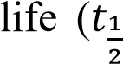) of the reaction is the time taken by the reactant to reduce to half of its initial concentration.

The expression for half-life of a first order reaction is obtained from the integrated rate law: i.e.

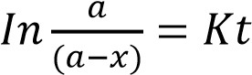

At t = 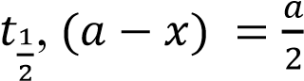 where 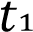 if half life

Then 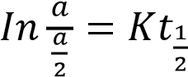
and thus, 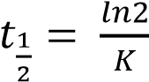
not that, In x = 2.303log x

This shows that in first order reaction, half-life is independent of the initial concentration of the reactants. The time necessary for the reactants to decrease to any other given fraction can be derived in the similar manner.

Trial 6
(a) The rate of a chemical reaction is given by the relationship:

Rate = K[A]ª[B]^{b}
State
(i) What each of the following stands for
[A] ………………………………………………… a …………………………………………………. b ……………………………………………………
(ii) One factor that can affect the constant K.
- Write an equation for the decomposition of dinitrogen oxide
- At 858K, the half-life of dinitrogen oxide is 75.09hours
Calculate
  - The rate constant for the decomposition of dinitrogen oxide
  - the total pressure after 75.09hours at 858K, if the initial pressure was one atmosphere.

Trial 7
- Derive the expression for the half-life for a first order reaction:
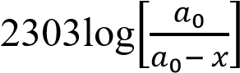= kt: Where 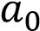 is the initial concentration of the reactant and 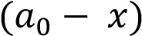 is the
concentration at time, t.
- The half-life of a first order reaction is 100s (i) calculate the rate constant.
(ii) Determine the percentage of the reactant that has reacted after 250s.

2. Zero order reactions

In a zero order reaction, the rate is independent of the concentration of the reactants.

A plot of the concentration [A] of the reactant against time has the form below:


The rate equ
ation for a zero order reaction:

[
A
]

time

Slope =
-
K

Rate = K[A]⁰ or Rate = K s⁻¹

Example, the reaction between iodine and propanone is a zero order with respect to iodine.

CH₃COCH₃ (aq) + I₂ acid CH₃COCH₂I(aq) + HI(aq)

Pseudo-order reaction
A pseudo order reaction is a reaction that is truly higher order but can be approximated to a lower order under special circumstances.

For instance, an elementary reaction between two reactants A and B is normally expected to be a second order; for example, hydrolysis of an ester and inversion of sucrose.
₊
H
CH₃COOC₂H₅ + H₂O CH₃COOH +CH₃CH₂OH
Cat
₊
H
C₁₂H₂₂O₁₁ + H₂O C₆H₁₂O₆ + C₆H₁₂O₆


^{Cat} Glucose fructose

However, if one of the reactant B is present at a very much greater concentration than that of A or else only acts as catalyst, then concentration of B is considered constant ad the rate law become

Rate = K’[A]

Such a reaction is said to be pseudo first order since the rate is proportional to concentration of A raised to the first power. Nevertheless, it must be remembered that the new constant (K’) in not a true constant because it also depends on the concentration of B. Since water is usually found in excess, the reactions given above are in practice found to be pseudo first order.

Note that:
- For a zero order reaction, any change in concentration of the reactant does not affect the rate of reaction.
- For a first order reaction increasing the concentration of the reactant two or three times also increases the rate two or three times.

Trial 8
- State what is meant by the term order of a reaction
- Methylethanoate is hydrolyzed by water in presence of an acid according to the following reaction:
CH₃COOCH₃ + H₂O (l) ↔ CH₃CH₂OH +C H₃OH
  - State the molecularity of the reaction
  - State the conditions under which the reaction can be overall first order

- The table below shows some kinetic data for the following reaction:
Expt. No. | [A) Moldm⁻³ | [B] Moldm⁻³ | Rate  Moldm⁻³ s⁻¹
1  2  3 | 0.20  0.20  0.40 | 0.20  0.60  0.60 | 1.2 x 10⁻⁸  1.2 x 10⁻⁸  4.8x 10⁻⁸

    - Write the overall order of reaction
    - Calculate the rate constant and give its units.

Measuring the rates of reactions
The rate of a chemical reaction can be obtained by following some property which alters with the extent of the reaction. By analyzing the reaction mixture at suitable intervals, it’s possible to determine the concentration of both the reactant and/or the product at different times and hence obtaining the rate (i.e. the rate at which the concentration of a particular substance changes with time).

In practice, the rates may be measured by observing the rate of change of physical properties such as refractive index, volume, color, and if the reaction is sufficiently slow, its rate may be found by frequent withdrawal of small portion of the reacting mixture and analyze then chemically at intervals.

Examples 2

1. An experiment to measure the rate of chemical reaction in which a gas is produced such as
Mg (s) + 2HCl (aq) → MgCl₂ (g) + H₂ (g)
Or 2H₂O₂ (aq) → 2H₂O (l) + O₂ (g)

The volume of a gas is recorded at intervals

Apparatus

1

2

3

4

- H₂O₂ solution and catalyst.
- Plunger of syringe moves outwards.
- Oxygen: Volume is recorded at certain times after the start of the reaction (d) Thermostat bath maintains temperature.

(e) The rate of reaction is given by 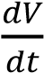 where V is the volume of the gas.

2. An experiment to determine the order reaction with respect to iodine in the reaction of iodine with propanone in presence of acid catalyst.
- Fixed volume of standard Iodine solution is added to an excess of propanone solution in a flask.

- To this mixture is added a fixed volume of dilute sulphuric acid and a stop clock started immediately.

- At intervals of time say (every 10 minutes for 50minutes) a specified portion is pipetted from the mixture and into a flask containing sodium hydrogen carbonate which stops the reaction.

- The resultant mixture is titrated with standard sodium thiosulphate using starch indicator.

- The volume (V_{t}) of thiosulphate used on the portion of mixture after a specified time (t) is proportional to the amount of iodine remaining in the mixture.

- The initial amount of iodine (V₀) is obtained by titrating a similar portion of the original mixture with sodium thiosulphate solution.

- A plot of the graph of V_{t} against time gives a straight line as shown below showing that the order of reaction with respect to iodine is zero.


Time, t (min)

V
t

NB. The gradient gives the rate constant whose units is molcm⁻³ s⁻¹.

Activated complex
With exception of radioactive disintegration all elementary reaction occurs via a transition state, for example, substitution reaction is expected to proceed as below

A + BC ↔ [A….B…..C] ↔ AB + C

In order to form the transition state, the reactants must first acquire activation energy i.e. This is the minimum energy required for the reaction to take place. Being energy rich, the transition species is unstable one and cannot be isolated and is usually referred to as activation complex. This may decompose either to give the product or original reactants. The energy variation during the above process may be represented by the figures below:

Definition
An activated complex is the structure that results in the maximum energy point along the reaction path.

The energy diagram for the reaction for exothermic reaction


Products

Potential
energy

Activated
complex

Reaction coordinates/

Path of a reaction

Reactant
s

a.E

a.E = activation
energy

-
∆
Hr

The energy diagram for the reaction for endothermic reaction


Reaction coordinates/

Path of a reaction

Activated
complex

Products

Potential
energy

Reactan
t
s

Ea.

Ea. = activation
energy

+
∆
Hr

The difference between the energy of the reactants and the product is the enthalpy of the reaction (∆Hr) which is negative for exothermic reaction (i.e. energy given out during the reaction and the reaction mixture heats up) or positive for endothermic reaction (i.e. energy is required for the reaction to take place.)

Definition
The molecularity of a reaction is defined as the number of molecules or ions that participate in the rate determining step.

The activation energy of a chemical reaction is the difference between the energy of the activated complex and the energy of the reactants.

Factors that affect the rate of reaction
The main factor which influence reaction rate are
- concentration of the reactant
- temperature
- Pressure
- presence of light
- the size of the particles for solid reactants.
- Catalyst

1. Particle size
The smaller the particle sizes the faster the reaction in solid state because of increase surface area for contact. e.g.

CaCO₃(s) + 2HCl (aq) → CO₂(g) + CaCl₂(aq) + H₂O(l)

The reaction is faster when CaCO₃ is in powder form than big chips.

2. Concentration
The higher the concentration of reactants; the faster is the rate of reaction due to increase in the rate of collision among the reacting molecules.

3. Pressure
Pressure increases the rate of reaction when the reactants are in gaseous phase because it increases the proximity and the rate of collision of the reacting molecules.

4. Temperature
Temperature increases the rate of reaction because
- Particles gain kinetic energy which increases the rate collision
- it increases the fraction of molecules with energy equal or higher than the activation energy that enables the reaction to take place in case collision take place between molecules.
The graph below shows the distribution of kinetic energies of molecules of a gas at temperatures T₁ and T₂; T₂ being higher than T₁.
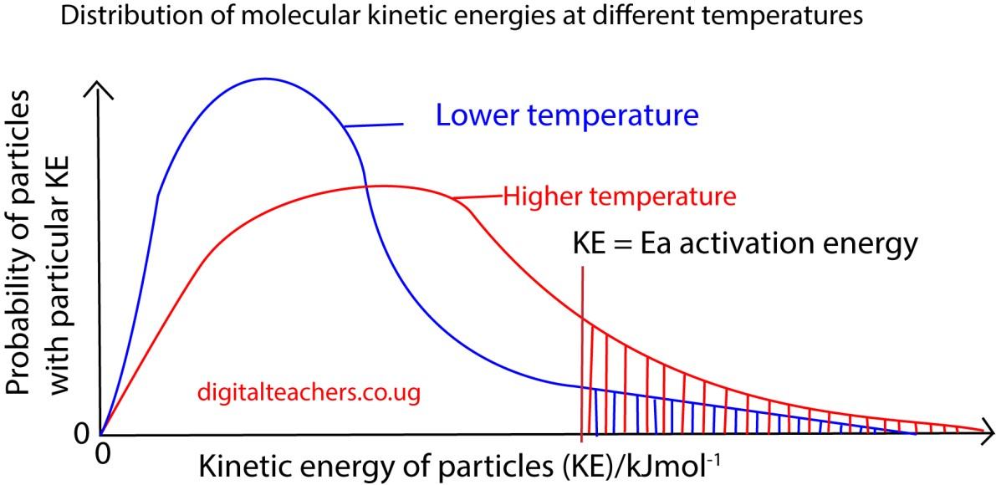

T
he number of molecules with energy equal to or greater then Ea increases rapidly with
temperature as shown by the shaded area under graph above

5. Light
Some reactions are catalyzed by light such as photosynthesis and formation of silver from silver salts that take place when a photographic film is exposed to light. The higher the light intensity, the higher the rate of reaction will be.

Surface area
Increasing surface area of the reactant increase the rate of reaction because it brings the reacting substances into more intimate contact to facilitate their interaction.

Catalyst
Increase the rate of reaction by lowering the activation energy
The energy diagram for the reaction for exothermic reaction in absence and presence of a catalyst
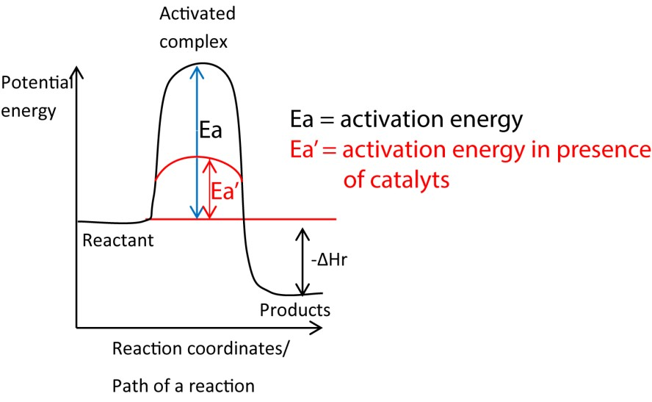

Trial 9
The tale below shows the initial rate of the reaction.

X + Y → Z
Varies with different starting concentrations of X and Y.


[
X] mol

[
Y] mol

Initial rate mol s
-
1

0.200

0.200

4.0
x
10
-
5

0.200

0.400

4.0
x
10
-
5

0.400

0.200

16.0
x
10
-
5

- Determine the order of the reaction with respect to
  - X
  - Y
- Write the rate equation for the reaction
- Calculate
  - the rate constant
  - the rate of the reaction when [X] = 0.100M and [Y] = 0.200M.

Trial 10
The table below shows the rate of the reaction between substances A ad B at different concentration

EXpt. | Initial concentration Mol dm⁻³ of |  | Initial rate of reaction Mol dm⁻³ s⁻¹
EXpt. | A | B | Initial rate of reaction Mol dm⁻³ s⁻¹
1 | 0.50 | 0.50 | 2.0 x 10⁻²
2 | 1.00 | 0.50 | 8.0 x 10⁻²
3 | 1.00 | 1.00 | 16.0 x 10⁻²

(a) Determine
- The order of reaction with respect to A and B
- Overall order of the reaction
(b)(i) Write the expression for the rate of the reaction.
(ii) Calculate the rate constant for the reaction and state the units.

Trial 11
(a) Differentiate between order and molecularity of reaction (5marks) (b) The table below shows some data for the reaction
A + 2B →C ∆H = +Q kJ mol⁻¹:

EXpt. | Initial concentration Mol dm⁻³ of |  | Initial rate of reaction Mol dm⁻³ s⁻¹
EXpt. | A | B | Initial rate of reaction Mol dm⁻³ s⁻¹
I | 1.00 x 10⁻² | 2.80 x 10⁻³ | 2.1
II | 5.00 x 10⁻³ | 2.80 x 10⁻³ | 1.1
III | 1.00 x 10⁻² | 5.60 x 10⁻³ | 4.3

- determine the order of the reaction with respect to A and B
- Write the rate equation for the reaction
(iii)Calculate the rate constant for the reaction and give its units
- Calculate the rate of reaction when the concentration of A and B are 8.50 x 10⁻³ mol dm⁻³ and 3.83 x 10⁻³ mol dm⁻³ respectively.
- State what would happen to the order of the reaction in (b) if B was present in larger excess. Explain your answer.
- draw a fully labeled energy diagram for the reaction I (b) (4marks)

Trial 12
The data in the table below was obtained foe the reaction
2A → Product
Time  (hr) | 0 | 1.3 | 2.0 | 4.0 | 5.3
Log₁₀[A] | -0.07 | -0.24 | -0.33 | -0.57 | -0.74

- Plot a graph of Log₁₀[A] against time.
- From the graph, determine the order of reaction.
- Calculate
  - the rate constant for the reaction.
  - the half-life of the reaction.

Trial 13
Propanone reacts with iodine in the presence of an acid catalyst according to the equation.

O O


CH₃CCH₃ + I₂ CH₃CCH + HI

The reaction is first order with respect to propanone and independent of the concentration of iodine.
- Explain the term order of reaction
- Write the expression for the rate law for the reaction
- Describe briefly how the order of the reaction with respect to iodine can be determined (8marks)

Trial 14
(a) Figure below shows the energy diagram for the reaction between nitrogen monoxide and oxygen



NO
2
2

NO + O
2
2

K

L

Energy (kJmol
-
1

Reaction co
-
ordinate

- Identify K and L (½ each)
- State whether the reaction is endothermic or exothermic (½ mark)
- Give a reason for your answer (a)(ii)
(b) The experiment results in the table below were obtained for the reaction (a)

Initial concentrations (moldm⁻³) |  | Rates of reaction (moldm⁻³s⁻¹)
NO | O₂ | Rates of reaction (moldm⁻³s⁻¹)
0.03 0.03  0.06 | 0.03 0.06  0.03 | 2.7 x 10⁻⁵  5.4 x 10⁻⁵  10.8 x 10⁻⁵

- deduce the order of the reaction with respect to
Nitrogen monoxide (1mark)
Oxygen (1mark)
- Write the rate equation for the reaction
(½ mark)
(c) Calculate the overall
  - overall order of reaction ( ½ mark)
  - rate constant (K) for the reaction and state its units (1½ marks)

Trial 15
- State what is meant by the following terms ‘order of reaction’ and ‘Half-life’ of a reaction
- A compound B decompose according to the following equation 2B product
The table below shows the concentration of B at various times
Time  (minute) | 2.0 | 4.0 | 7.0 | 10.0 | 14.0 | 20.0
[B] (moll⁻¹) | 0.820 | 0.670 | 0.490 | 0.372 | 0.240 | 0.141

Draw a graph of log₁₀[B] against time. (05marks)
- Using the graph, determine the:
  - Original concentration of B
  - Order of the reaction
  - Rate constant for the reaction
  - Half-life for the reaction
- (i) Using the same axes, draw a labelled diagram for energy-reaction coordinate for a catalyzed and uncatalyzed reaction
(3½marks)
(ii) State the difference in your diagrams (1mark)
(iii)State how a catalyst increases the rate of reaction (2marks)

Trial 16
- Describe an experiment that can be carried out to show that the catalytic decomposition of hydrogen peroxide is a first order reaction. (09marks)
- The rate of a certain reaction is
Rate =K[A][B]²[C]
Where [ ] is the concentration in moles per litre and K is the rate constant

Show how the rate of reaction would change if:
  - [B] and [C] were kept constant and [A] was doubled. (1mark)
  - [A] and [C] were kept constant and [B] was halved. (1mark) (iii) [A] and [C] were kept constant and [B] was doubled. (1mark) (iv) [A], [B] and [C] were doubled.

Trial 17
(a) (i) Define the term radioactivity.
(i) Name three types of radiations emitted during radioactivity and state how they affect the nucleus of radioisotope. (04marks)
(b) The table below shows how the mass of radioactive protactinium, 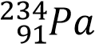varies with time
Mass of 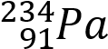g | 60.0 | 38.5 | 26.0 | 17.2 | 11.1
Time  (minute) | 0 | 40 | 80 | 120 | 160
- Plot a graph of mass of protactinium against time (03marks)
- Use your graph to determine half-life of protactinium. (2marks)
(iii)Calculate the radioactive decay of protactinium (2marks)
(iv) Determine the time taken for 8g of protactinium to decay to 1g (2marks)
(c) Briefly describe how
- Carbon-14 can be used to determine the age of archeological objects (3marks)
- Oxygen-18 can be used to determine the mechanism for esterification of a mon carboxylic acid with a primary alcohol (4marks)

Trial 18
- Differentiate between order of reaction and molecularity. (2marks)

- The table below shows kinetic data for the following reaction.
5Br⁻(aq) + BrO₃⁻(aq) + 6H⁺(aq) → 3Br₂(aq) + 3H₂O (l)
Volume of BrO₃⁻/cm³ | 3.0 | 4.0 | 5.0 | 6.0 | 8.0 | 10.0
Time (t)/s | 69.0 | 45.0 | 35.0 | 31.0 | 24.0 | 18.5
- Plot a graph of 1/t against volume of bromate (V), BrO₃⁻.
- Determine the order of reaction with respect to bromate (V) and give a reason for your answer. (1mark)
(iii)Determine the rate constant for the reaction and state its units. (1mark)
(iv) Write equation for the rate of reaction in terms concentration of BrO₃⁻ (1mark).of

Suggested answers
Trial 1
- (i) Reaction rate is the speed at which a chemical reaction proceeds. It is often expressed in terms of either the concentration (amount per unit volume) of a product that is formed in a unit of time or the concentration of a reactant that is consumed in a unit of time.
    - Order of reaction is the sum power dependence of the rate on the concentration of each reactant.
    - Stoichiometry of a reaction is the quantitative relationships of the amount of products and reactants in a given reaction
    - The rate constant of the reaction is a proportionality factor in the rate law of chemical kinetics that relates the molar concentration of reactants to reaction rate
- The experiment were carried out at constant temperature in order to eliminates changes in the rate of reaction due to changes in temperature
- (i) the order of reaction with respect to A is derived using values of experiments 1 and 2
i.e, 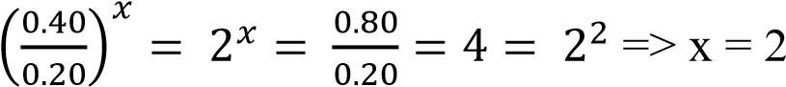
the order of reaction with respect to is derived by using values of experiment 2 and 3
i.e, 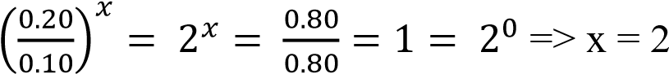
Rate equation: rate = K[A]².
(ii) Substituting values of experiment 1
0.2 = K(0.2)²
K = 5mol⁻¹dm³s⁻¹
(iii) Substitution in rate equation
Rate = 5 (0.6)² = 18moldm⁻³s⁻¹

Trial 2
- Rate equation: rate = K[A][B]²
- K = 1.49 x 10⁻³ mol⁻²dm6s⁻¹
- Rate = 8.67 x 10⁻⁶moldm⁻³s⁻¹
Trial3
  - Rate = K[NO]^{x}[O3]^{y}
  - Order of reaction with respect to NO = 1
Order of reaction with respect to O3 = 1
  - Rate = K[NO][O₃]
  - K = 2.2 x 10⁻⁷mol⁻¹s⁻¹
Trial 4
  - Order of reaction with respect to X = 1 Order of reaction with respect to Y = 1
  - Overall order = 1+ 1 = 2
  - K = 0.3mol⁻¹dm³s⁻¹
Trial 5
(a) (i) the rate doubles
(ii) The rate is multiplied by 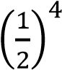 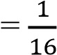
(iii)The rate is multiplied by 2⁴ = 16 (b) (i) Order of reaction with respect to (S₂O₈²⁻) = 1 Order of reaction with respect to I⁻ = 1 Rate equation:
Rate = K[S₂O₈²⁻][ I⁻]
(ii) Rate constant K = 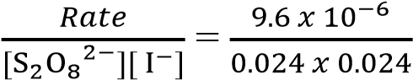 = 0.017mol⁻¹dm³s⁻¹
Trial 6
- [A] = concentration of a a = order of reaction with respect to concentration of A b = order of reaction with respect to concentration of B
- Temperature
- (i) rate constant K = 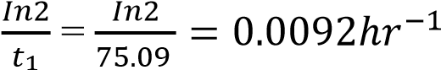
(ii) N₂O(g) → N₂(g) + ½ O₂(g)
Moles of gas after halt-life = moles of N₂O + Moles of N₂ + moles of O₂
= 0.5 + 0.5 + 0.25
= 1.25
Since pressure is proportional to the number of moles of gases
The final pressure = 1 x 1.25 = 1.25 atmospheres

Trial 7
- Time = half-life; => a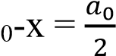
It implies that; 2.3031log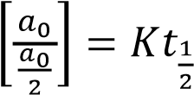
2.3031log 2 = K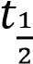
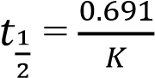
- K = 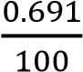 = 6.93 x 10⁻³s⁻¹

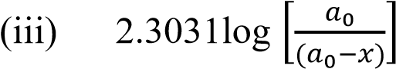= 6.93 x10⁻³ x 250
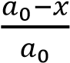= 0.177 or 17.7%
Trial 8
- (i) 2
(ii) when water is in excess
- Order of reaction with respect to A = 2
Order of reaction with respect to B = 0
Overall order = 2 + 0 = 2

Rate constant K = 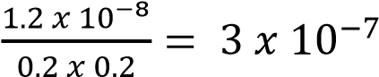mol⁻¹dm³s⁻¹
Trial 9
  - X = 2
Y = 0
  - Rate = K[X]²
  - (i) K = 1 x 10⁻³mol⁻¹dm³s⁻¹
(iii) 1 x 10⁻⁵moldm⁻³s⁻¹
Trial 10
(a) (i) order of reaction with respect to A =2 Order of reaction with respect to B = 1
(ii) overall order = 1 + 2 =3
(b) (i) Rate = K[A]²[B]
(ii) K = 0.16mol⁻²dm⁶s⁻¹
Trial 11
- Order of reaction is the sum power dependence of the rate on the concentration of each reactant while molecularity is the number of molecules or ions that participate in the rate determining step.

- (i) order of reaction with respect to A = 1

Order oof reaction with respect to B = 1
- Rate = K[A][B]
- K = 7.5 x 10⁵mol⁻¹dm3s⁻¹
- 24
- Becomes pseudo order 1
Trial 12
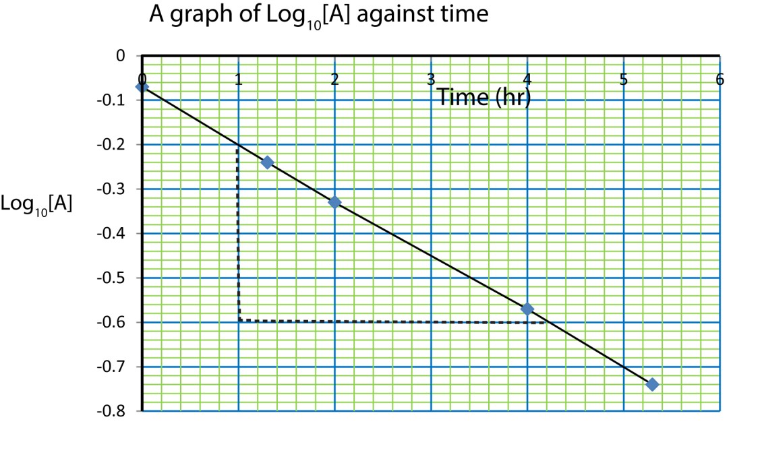
(a)
(
b
)

T
he reaction is first order since the shape of the graph suggests that the rate is
proportional to concentration of the reactant.

(c) (i) Rate constant K = negative slope
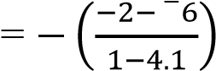
= 1.29hr⁻¹
(iii) Half-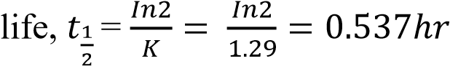
Trial 13
- Order of reaction is the sum power dependence of the rate on the concentration of each reactant.
- Rate = K[CH₃COCH₃]
- An experiment to determine the order reaction with respect to iodine in the reaction of iodine with propanone in presence of acid catalyst.
  - Fixed volume of standard Iodine solution is added to an excess of propanone solution in a flask.

  - To this mixture is added a fixed volume of dilute sulphuric acid and a stop clock started immediately.

(iii)At intervals of time say (every 10 minutes for 50minutes) a specified portion is pipetted from the mixture and into a flask containing sodium hydrogen carbonate which stops the reaction.

  - The resultant mixture is titrated with standard sodium thiosulphate using starch indicator.

  - The volume (V_{t}) of thiosulphate used on the portion of mixture after a specified time (t) is proportional to the amount of iodine remaining in the mixture.

  - The initial amount of iodine (V₀) is obtained by titrating a similar portion of the original mixture with sodium thiosulphate solution.

  - A plot of the graph of V_{t} against time gives a straight line as shown below showing that the order of reaction with respect to iodine is zero.

Time, t (min)

V
0

NB. The gradient gives the rate constant whose units are molcm⁻³ s⁻¹.
Trial 14
(a) (i) K = activation energy L = enthalpy of reaction
    - exothermic
    - Products have less energy than reactants
The order of reaction with respect to [NO] = 2

Order of reaction with respect to [Y] = 1
(ii) Rat = K[NO]²[O₂)
(c) (i) Overall order = 2 + 1 = 3
(ii) K = 1mol⁻²dm⁶s⁻¹

Trial 15
- Order of reaction is the sum power dependence of the rate on the concentration of each reactant
- Half-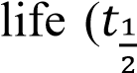) of the reaction is the time taken by the reactant to reduce to half of their initial concentration.
Time  (minute) | 2.0 | 4.0 | 7.0 | 10.0 | 14.0 | 20.0
[B] (moll⁻¹) | 0.820 | 0.670 | 0.490 | 0.372 | 0.240 | 0.141
Log [B] | -0.086 | -0.173 | -0.309 | -0.429 | -0.619 | -0.850

(b)
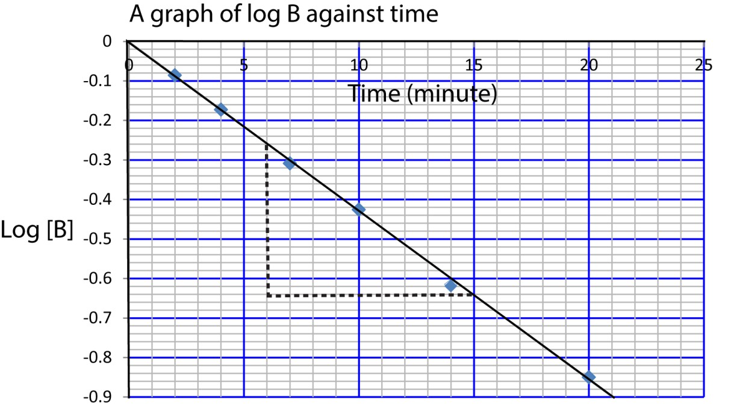
(c)(i) Log B = 0
B = 10⁰ = 1
(ii) Order of reaction is first order since the rate is proportional to concentration (iii) Rate constant K = negative slope
(iv) Half-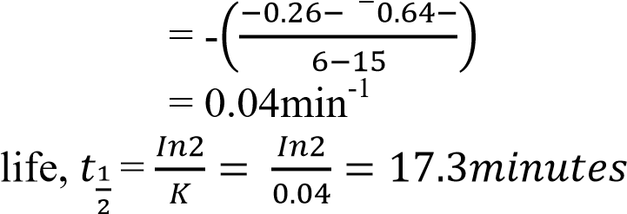
(d)(i)

- the catalyzed reaction has lower activation energy
- A catalyst increase the rate of reaction by lowering activation energy.

